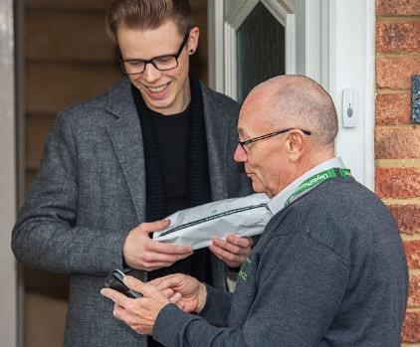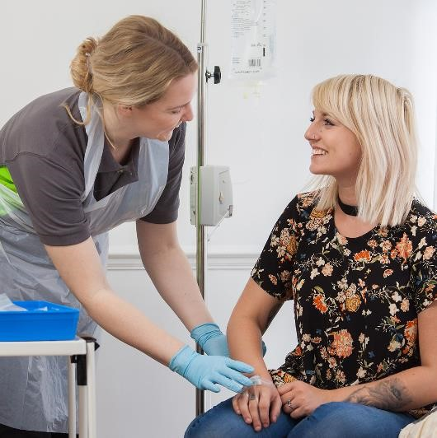

**Duty of Candour Report 2022-2023**

**Service provider details**

Service provider details

**Service name:** Lloyds Pharmacy Clinical Homecare

**Service Type Detail:** Nurse Agency

**Service number:** CS2009235447

**Service address:** Unit 3, Weardale Lane, Queens lie Industrial estate, Glasgow, G33 4JJ.

**Registered Managers:** Carolynne Allan

**Organisation/provider**

Service provider details

LloydsPharmacy Clinical Homecare (LPCH) provide clinical homecare to over 100,000 patients to enable them to live their very best lives. As one of the most experienced providers of clinical homecare in the UK market, we care for patients in their own home or in the community on behalf of our NHS, private medical insurers, and pharmaceutical manufacturing partners. Our services range from the straightforward delivery of medication to specialist nursing for complex conditions.

LloydsPharmacy Clinical Homecare is registered with Companies house; 02764914.

**Scotland Staff Team:**

**Registered Managers:** Carolynne Allan.

Staff team: 1 senior homecare nurse. 4 registered nurses.

Service provider details

**How many incidents happened to which the duty of candour applies?**

In the past year, there have been **six incidents** to which the Duty of Candour applied. [These are situations where unintended or unexpected incidents occurred, **not directly related to the natural course of someone’s illness or underlying condition**](https://www.vsa.org.uk/duty-of-candour-report). None of these incidents were related to nursed patients.

|  |  |
| --- | --- |
| **Type of unexpected or unintended incident** | **Number of times this happened.** |
| Someone has died | 0 |
| Someone has permanently less bodily, sensory, motor, physiologic or intellectual functions | 0 |
| Someone’s treatment has increased because of harm | 0 |
| The structure of someone’s body changes because of harm | 0 |
| Someone’s life expectancy becomes shorter because of harm | 0 |
| Someone’s sensory, motor, or intellectual functions is impaired for 28 days or more | 0 |
| Someone experienced pain or psychological harm for 28 days or more | 0 |
| A person needed health treatment to prevent them dying | 0 |
| A person needing health treatment to prevent other injuries | 6 |

Service provider details

**To what extent did LPCH follow the Duty of Candour procedure?**

During our Serious Incident Meetings, LPCH established the Duty of Candour requirement, and we followed the correct procedure in 6 out of the 6 occasions. This means we informed the people affected and apologised to them.

Departmental complaints and Corrective and Preventative Action Plans are shared during our monthly Quality, Patient Safety & Risk Management Committee Meeting.

Two of these incidents were related to a product failure and not a direct result of LPCH. A replacement product was delivered following the complaint being raised to LPCH. Duty of candour was completed due to the transfer of care whilst the replacement product was arranged as per policy.

Service provider details

**Information about our policies and procedures**

All complaints and incidents requiring Duty of Candour are reported onto the LPCH incident management system as per the standard complaints and incident processes. Incidents graded as moderate harm or above have an escalation call, where the need to enact Duty of Candour is discussed. Once it has been determined that Duty of Candour should be completed, a named individual will be allocated to undertake this verbally as soon as practically possible following notification of the event. If the Duty of Candour is related to a nursed patient, then this would be report to the Care Inspectorate. No cases this year are related to a nursed patient. All Duty of Candour discussions are followed up in writing by the Clinical Governance and Patient Experience Team as per our Duty of Candour Policy.

When an incident has happened, the Manager and Clinical Governance and Patient Experience Team review a Corrective and Preventive Action Plan to avoid recurrence. This allows LPCH to review what happened and identify changes for the future.

We acknowledge that serious mistakes can be distressing for staff as well as people who use care and their families. We have occupational welfare support, clinical supervision, and an Employee Assistance Program in place for our staff if they have been affected by a duty of candour incident.

Service provider details

**What happened as a result?**

We have made several changes to our procedures as a result of the duty of candour. The significant changes that we wish to highlight:

* Implementation of recruitment evenings within Patient Services to improve available resource within the team.
* As a result, our average speed of answer is now within 2 minutes and frequently reporting days within 60 seconds.
* New shift leader and real time analyst roles created within our patient services team to improve the quality of service.
* Prescription Forecasts automatically update according to a patients schedule to ensure requests go out when required, this now prevents LPCH from requesting prescriptions too early leading to prescriptions expiring before use, this also helps us receive a prescription prior to patients missing doses.
* Prescriptions are now built directly from our system instead of via paper, prescriptions are scanned in as a first point onto the system within 24 hours, this change helps prevents original prescriptions moving from team to team which was a cause behind lost/ missing prescriptions.
* With the movement of prescriptions to Scimitar Park from Glasgow, a central location for prescriptions, this has removed the risk of delayed prescriptions being transferred between two locations.

As required, we have submitted this report to the Care Inspectorate, and we have also placed it on our website. If you would like more information about this report, please contact us using these details: caiteam@lpclinicalhomecare.co.uk